Plans and Progress

### Raspberry Pi and Safety Mechanism

As discussed, the backbone of this proposed project is a Raspberry Pi – a small, single board-computer that takes keyboard and mouse inputs and depending on the model selected can connect to the internet or other devices via Bluetooth (*What is a Raspberry Pi?* 2013). Essential to the plan of this project is that the Raspberry Pi also provides GPIO (general purpose input/output pins) which will allow for inputs from other devices, such as a relay board and sensors, that enable its IoT use-case (*What is a Raspberry Pi?* 2012). Comparing the various models available (*RaspberryPI models* 2020), any of the Raspberry Pi 3 models will be able to fulfill the needs of this project thanks to their in-built wireless and Bluetooth capabilities, and are available from a number of electronics and computer stores (such as PiAustralia <<https://raspberry.piaustralia.com.au/>>, Core Electronics <<https://core-electronics.com.au/>> or uMart <<https://www.umart.com.au/RaspberryPi_431B.html>>) as well as large online marketplaces like Amazon and eBay.

Connecting the Raspberry Pi to a 5V two channel relay module, available from the same locations the Raspberry Pi is, which in turn is connected to the garage door opening mechanism, will allow the Raspberry Pi to control the mechanism. A sensor of some form is required so that the Raspberry Pi knows whether the door is open or closed, a key intended feature of the product. Looking at products previously mentioned in the Landscape section of this report it is clear that there are a number of potential methods to achieve this. Some, such as the Gogogate 2 and Aeotec Z-wave, use a sensor that measures the tilt of the device, therefore indicating that the door is closed when the sensor is upright and open when it is horizontal, while others such the Garadget use a laser directed at a reflector on the door with a corresponding receiver. We propose using magnetic switch/reed switch such as the switch available here <https://core-electronics.com.au/magnetic-contact-switch-door-sensor.html>, due to its cost and because they are a proven system that have been used in alarm systems for many years. With the sensor portion attached to the rail that guides the chain/belt near the opening mechanism and the magnet attached to the arm that pulls the door itself, so that they are adjacent to each other as pictured below, the system will be able to determine if the door is fully open or not.

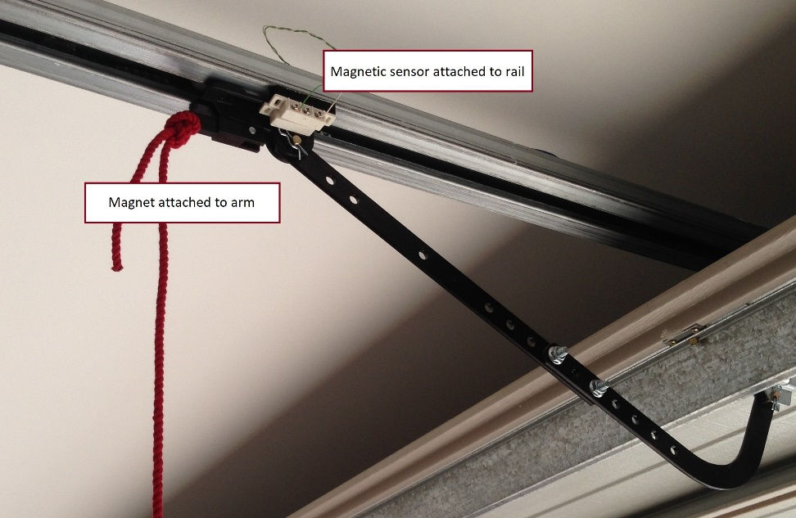

(Figure #: Configuration of sensor to determine door status)

Were it desired to be known when the door was fully closed, a second sensor could be placed on the door rail near the ground, with a magnet attached to the door such that they were adjacent when the door is closed, although this would add complexity to the wiring required.

The original project proposal outlined a plan to use a camera (*Camera Module - Raspberry Pi Documentation* 2013) along with TensorFlow (*TensorFlow Lite | TensorFlow Lite | TensorFlow* 2019), a machine learning algorithm, to recognise objects such as animals and children and act as a safety mechanism to prevent the door being closed remotely and injuring them. However, after further review it was determined that a camera may not be suitable, particularly as object detection in 3D is not well developed at present (Ahmadyan & Hou 2020) and requires more processing power than a Raspberry Pi can provide.

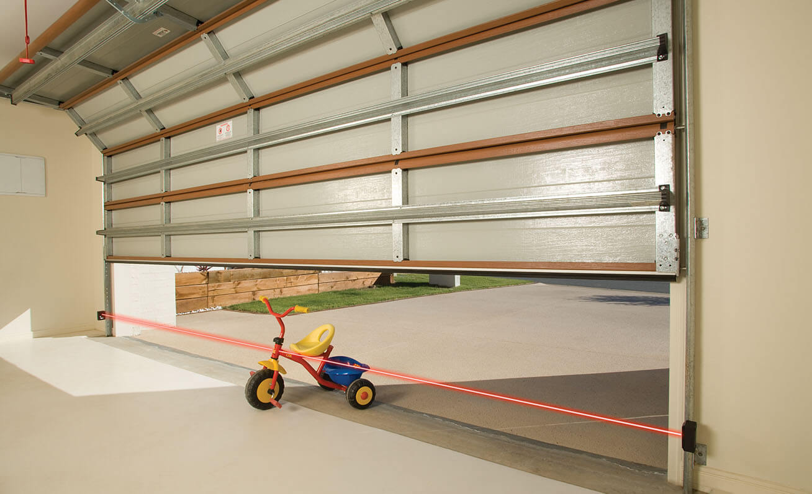

(Image: B&D Garage Doors, Photo Electric safety beam)

Current safety mechanisms used by garage door manufacturers use a photo electric beam sensor, which uses an infra-red beam and sensor to determine the presence of an obstruction. An uninterrupted signal to the sensor indicates a clear path which therefore allows the door to close, while no sensor indicates the opposite. A similar sensor can be created using infra-red LEDs and sensors (*Long Range Beam Break Sensor with Reflector Panel* 2018), and be paired with a reflector panel so that any wiring only needs to go one side of the door.

(Figure #: Schematic of system)

As explained in the Aims section, the Raspberry Pi will be programmed using Python due to its beginner-friendly nature and its ease of use due to being one of the default languages within the Linux distribution run on the Pi by default, Raspbian. Numerous examples of code that could be used as the basis of this project are available on various websites, blogs and GitHub, however all would need to be heavily modified to both integrate the proposed safety mechanism at a minimum and for academic and intellectual integrity.

Ahmadyan, A & Hou, T 2020, *Real-Time 3D Object Detection on Mobile Devices with MediaPipe*, Google AI Blog, viewed 18 May 2020, <https://ai.googleblog.com/2020/03/real-time-3d-object-detection-on-mobile.html>.

‌*Camera Module - Raspberry Pi Documentation* 2013, Raspberrypi.org, viewed 14 May 2020, <https://www.raspberrypi.org/documentation/hardware/camera/>.

‌*Long Range Beam Break Sensor with Reflector Panel* 2018, Hackster.io, viewed 28 April 2020, <https://www.hackster.io/mova2/long-range-beam-break-sensor-with-reflector-panel-4dfc48>.

‌*RaspberryPI models comparison | Comparison tables - SocialCompare* 2020, socialcompare.com, viewed 14 May 2020, <https://socialcompare.com/en/comparison/raspberrypi-models-comparison>.

*TensorFlow Lite  |  TensorFlow Lite  |  TensorFlow* 2019, TensorFlow, viewed 14 May 2020, <https://www.tensorflow.org/lite>.

*What is a Raspberry Pi?* 2012, Opensource.com, viewed 14 May 2020, <https://opensource.com/resources/raspberry-pi>.

*What is a Raspberry Pi?* 2013, Raspberry Pi, viewed 13 May 2020, <https://www.raspberrypi.org/help/what-%20is-a-raspberry-pi/>.

‌